14.1 Intro Surfaces and Level Curves
Def’n:
A function, f, of two variables assigns a number for each input (x,y)
$$z = f\left(x,y\right).$$

(x,y) = location on the xy-plane.
z = f(x,y) = height above that pt.

We sometimes write $f:R^{2}\overset{→}{}R$.

Our main visualization tool is level curves
(traces for z = k, a constant)

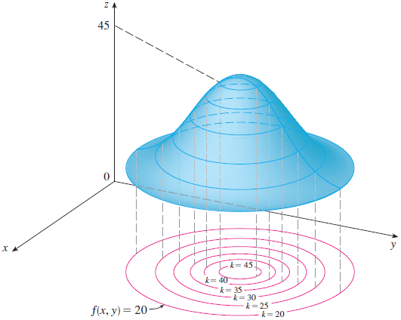

Appears in Function | Restriction
$$\sqrt{BLAH}$$ | BLAH ≥ 0
STUFF/BLAH | BLAH ≠ 0
ln(BLAH) | BLAH > 0
sin⁻¹(BLAH) | -1 ≤ BLAH ≤ 1
and other trig…
Domain: HW Q1-3
The set of allowable inputs.
This will be a region in 2D.

Examples:
Sketch the domain of
- $f\left(x,y\right)=ln(y-x)$

- $g\left(x,y\right)=\sqrt{y+x^{2}}$

Domain Graphs: https://www.desmos.com/3d/bqztlhjibs
Level Curves (also called contour maps)
- Given $z=f\left(x,y\right)$
- Choose equally spaced-out values for z = k.
  - For each k value, graph the 2D curves $f\left(x,y\right)=k$on the ground.

Examples: HW Q4-6
- Graph level curves for
$$z = sin(x) - y$$

Drawing Level Curves: https://www.desmos.com/3d/2iu7hz8kim

- Graph level curves for
$$z=f\left(x,y\right)=\frac{1}{1+x^{2}+y^{2}}$$

You have likely seen contour maps before
Here is a fun one…
Mount Saint Helen’s before and after 1980
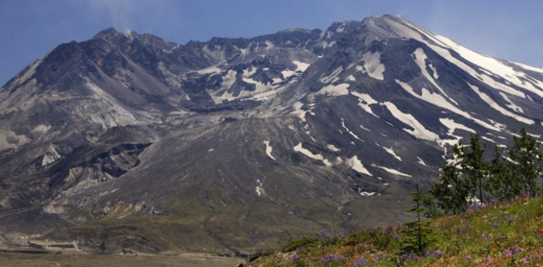
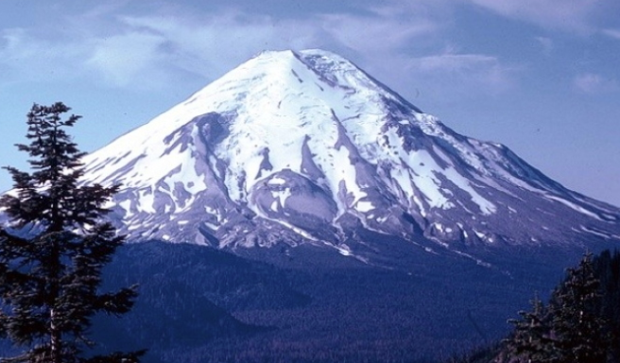

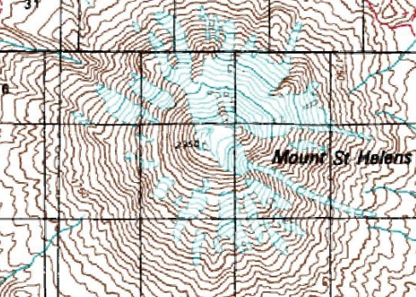

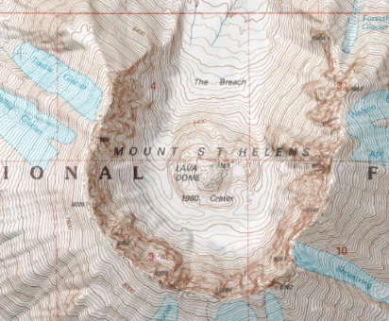

If you are having trouble with reading contour maps, then I encourage you to go to the REI website and they can teach you… HW Q8-13
https://www.rei.com/learn/expert-advice/topo-maps-how-to-use.html
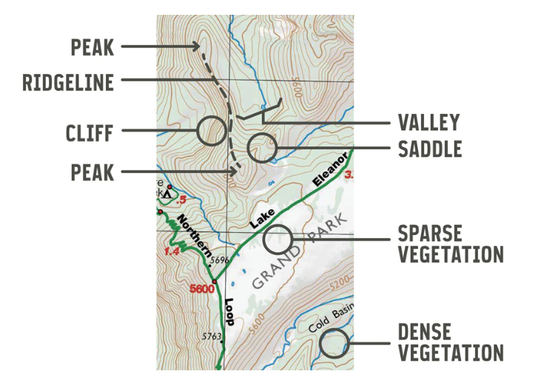

Tips for identifying graphs in HW:
- Plot points: f(0,0), f(0,1), f(1,0)
- Draw level curve: z = 0, z = 1, z = 2
- Special features:
  - Places undefined?
  - Behavior as x and y get bigger
  - Is it a wave if x (or y) is fixed?

Example: HW Q7
Match the function to the picture

A) $f\left(x,y\right)=\frac{1}{1+x^{2}+y^{2}}$
B) $f\left(x,y\right)=\frac{1}{1+x^{2}y^{2}}$
C) $f\left(x,y\right)=\ln\left(x^{2}+y^{2}\right)$
D) $f\left(x,y\right)=\cos\left(\sqrt{x^{2}+y^{2}}\right)$
E) $f\left(x,y\right)=|xy|$
F) $f\left(x,y\right)=\cos\left(xy\right)$

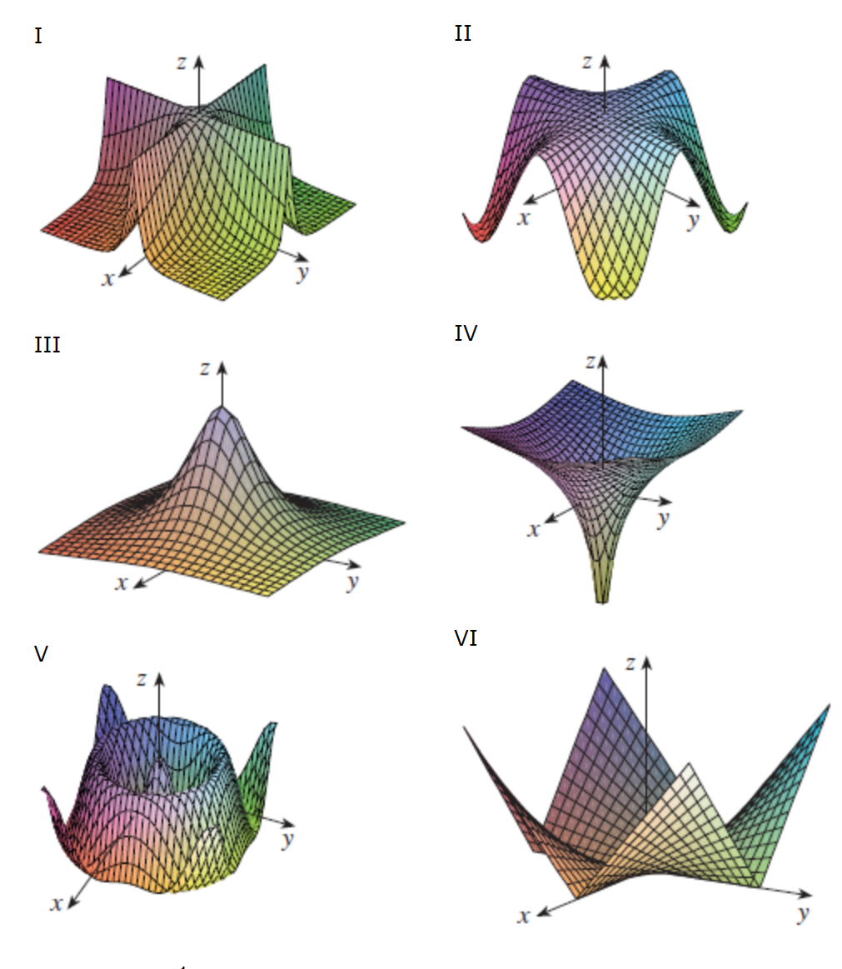

Rippling Wave: https://www.desmos.com/3d/2hb5veannv
A motivating contour map
Visual https://www.desmos.com/3d/432nc4iwoo

Questions:
If we walk along the surface from a given point in one of the indicated directions, will we walk uphill or downhill?

What would you need to know to answer?

Does it matter which way we go?

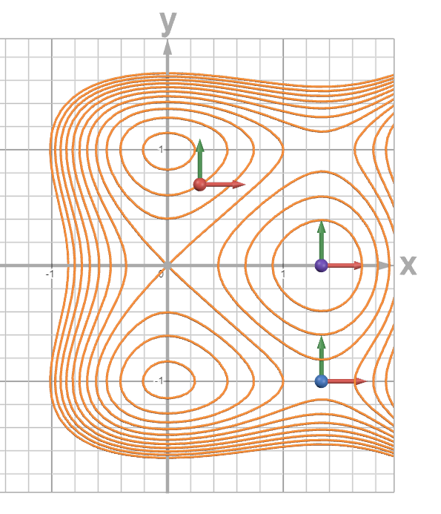

14.3 Partial Derivatives

Goal: Get slope in two different directions.

$${\frac{∂z}{∂x}=f}_{x}\left(x,y\right)=\lim_{h→0}{\frac{f\left(x+h,y\right)-f(x,y)}{h}}$$

$${\frac{∂z}{∂y}=f}_{y}\left(x,y\right)=\lim_{h→0}{\frac{f\left(x,y+h\right)-f(x,y)}{h}}$$

Example
$f\left(x,y\right)=x^{2}y-9y-xy^{2}+y^{3}$

Intro to Partial Derivatives: https://www.desmos.com/3d/fwmtqk43et

